SMP FD1/FD2 - Flange Spray Deflector Belt
Description and Instructions

The flange spray deflector belt is a tool that helps minimize the spray that is produced when a flange set is broken open and direct the spray into a known direction. Occasionally, when unbolting flanged connections some liquid or gas under pressure may spray out from between the flanges. This spray poses a danger due to chemical exposure, hot water and/or steam burns. This device is meant to help protect the worker and not to seal or contain any pressure.
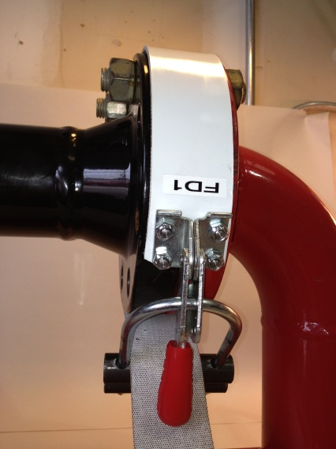

The flange spray deflector belt consists of a nitrile elastomer belt, u-bolt buckle and a cam over latch. Inspect the belt for any cuts, tears, burns or damage and replace or return any damaged tool before use. Wrap the belt around the bolted flanges prior to unbolting. Feed the free end over the top of the two rollers.

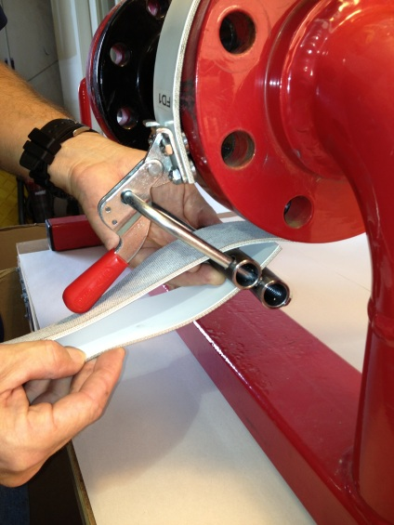

Then feed the free end back through the buckle, in between the two rollers.

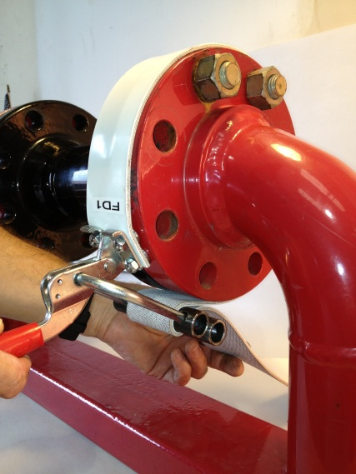

With the cam lock in the relaxed position pull the slack out of the belt till the belt is just snug around the flanges.

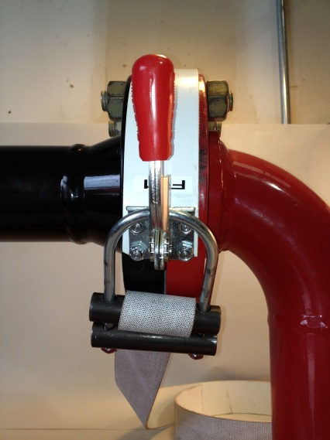
Arrange the buckle so that the flange access gap (pictured left) is pointed in a safe direction. The flange access gap allows the operator to use a pry bar to break the seal between flanges.
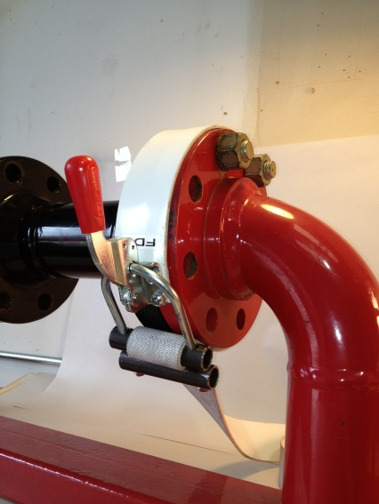

Engage the cam over. If the cam over is difficult to close loosen the belt slightly and try again. The belt is tightened correctly when the edges are firmly seated around the flanges and does not slip when pressure is applied at any point.

The flange spray deflector belt can be used for the following:
First line breaks
Hot bolting
Blinding
Low point breaks
Draining deflection and/or guiding

The flange spray deflector belt should NEVER be used for the following:
For lifting or support of any load
Holding flanges in alignment
Supporting an unbolted line, blind, valve or fitting
On surfaces that exceed 275 degrees F.

