LOKRITE Procedure: INDIVIDUAL UNIT

Tension release bolt will normally be set approximately 1/2" length extension.
(This is for all sizes of Lokrite units including Openend and Boxend style)
A longer bolt is provided for applications where studs are further apart, and the tension bolt has to be run out to hit reaction point properly.
(The tension release bolt should be closely pointed at the center of the corresponding stud) Example below.

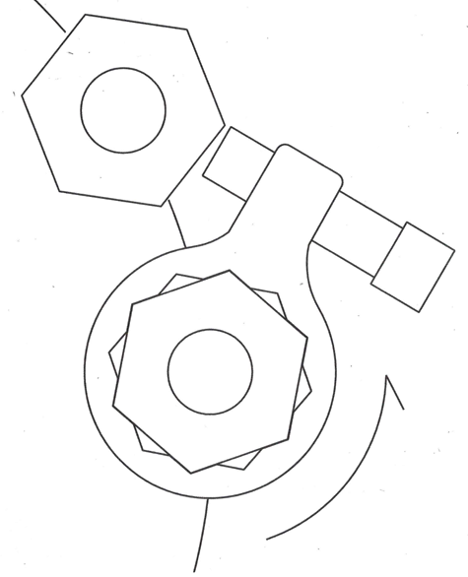

Unit will be set in place on nut with the label facing out.
Let unit rotate during applied torque until tension release bolt contacts reaction point (Normally nut on counter-clock wise side).
After torque is applied use separate wrench (EX: small crescent) to loosen tension release bolt.
Take unit off and proceed to next nut.

